2023 POSCO Asia Fellowship (PAF)
Recruitment Announcement

POSCO TJ Park Foundation operates 「POSCO Asia Fellowship(PAF)」program to support young prospective intellectuals to grow as global leaders through master’s or Doctoral courses in Korea.

We are looking for promising Asian students who will lead the 21st century with POSCO

1. Eligibility
• Asians that earned bachelor’s degree who have the potential to grow as a leader in their respective country
• Students seeking enrollment in Korean graduate school in Spring semester of 2023 and willing to study in Fall semester of 2023
• Students who hold Asian citizenship (who hold the citizenship of non-Asian countries or Korea are excluded)

2. Benefits
• Master’s: Tuition and living expenses for 4 semesters
• Doctoral & Integrated Ph.D.: Tuition and living expenses for 6 semesters
• National health insurance expenses, settlement expenses, online Korean classes and grant, etc.
• POSCO Seminar, Korean cultural experiences, etc.

3. How to apply
• Access the website during application period and submit application and evidential documents via Online
- Downloads the attached application form
- Fill out the application form
- Click the "online apply"
- Apply through online and attached the completed application form

• Documents to submit:
- Application and Statement of Purpose
- Recommendation Letter
- Certificate of Enrollment/Graduate/Employment
- Transcript
- Proof of Citizenship Document
- Certificate of language proficiency (*optional)

4. Schedule
• Application submission: September 5th ~ 19th (UTC+9) 23:59, 2022
*Based on Korean time
• Interview: January 2023
• Result announcement: January 2023
*The NEXT fellowship for 2024 students will open at May 2023.

※ Selection procedure
- Needs to apply your desire universities yourself separately.
- If you couldn’t submit the COA (Certificate of Admission) before your semester started, your fellowship could be canceled.
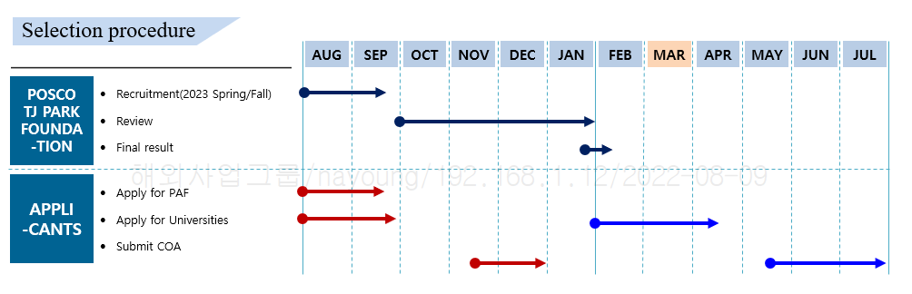

Application Checklist

- Name of Applicant:
- Country:
- Desired Program: ☐ Master's ☐ Ph.D. ☐ Integrated Ph.D.

* Please submit #4~11 combine as one PDF file or else, and check (√) in the appropriate box

Application Documents (*Mandatory) |  | Submission Status
 |  | Yes | No
1 | (Form 1) Application Form
2 | (Form 2) Statement of Purpose
3 | (Form 3) Recommendation letter *Max.2 letters
4 | Certificate of Bachelor’s degree or Bachelor’s Diploma (Original)
5 | Bachelor’s degree Transcript (Original)
6 | Applicant’s Proof of Citizenship Document (Original)

Application Documents (*Optional) |  | Submission Status
 |  | Yes | No
7 | Certificate of Master’s degree or Master’s Diploma (Original)  *Ph.D. program applicants only
8 | Master’s degree Transcript (Original)  *Ph.D. program applicants only
9 | Certificate of Employment (Original)
10 | Certificate of Valid English Proficiency Test  (TOEFL, TOEIC, TEPS, IELTS ONLY)
11 | Certificate of Valid TOPIK

Form 1. Application Form

Please type or print in Korean or English.

Ⅰ. Program to apply
Check the appropriate box and indicate your desired program of study (*only one program)
☐ Master's Degree ☐ Doctoral Degree ☐ Integrated Ph.D

Ⅱ. Desired University & Major

University | Division | Department | Major *Optional

※ Scholarships will be available ONLY for enrollment in universities and majors as above.
※ Needs to applying each university separately and bring certificate of admission yourself.
※ All kinds of MBA(business) and Academic programs offered evenings (night school), short-term seasonal programs, online and distant-learning programs are not available to apply and admission is not permitted.
※ If the choose university which have campus, you have to write down it.

Ⅲ. Personal Information
Photo  (3cm*4cm) | Full  Name | First/Given name | Last name/Surname
 | Nationality
 | Gender | ☐ Male ☐ Female
 | Date of birth | (yyyy.mm.dd)
 | Contact  Information | Address
 |  | Phone
 |  | E-mail

Ⅳ. Academic History
Period  (yyyy/mm/dd) | Name of University  (Or Graduate School) | Country | Department/Major | Degree | GPA
~
~
~

Ⅴ. Employment History
Period  (yyyy/mm/dd) | Institution/Company | Department | Responsibilities Detail
~
~
~

Ⅵ. Language Proficiency (including Korean) *TOEFL, TOEIC, TEPS /TOPIK Level
Date  (yyyy/mm/dd) | Language | Name of test | Score/Level

Ⅶ. Previously Received Scholarship Awards from Korean institutions
Period  (yyyy/mm/dd) | Title of scholarship | Sponsor | Amount (USD/year)
~
~

I declare that the information contained in this application is complete, accurate and true. I understand that any untrue, misleading or omitted information may result in my disqualification from further consideration for admission and may cause for the rescinding of any offer of admission, or for discipline, dismissal, or revocation of degree if discovered at a later date. I agree to abide by the rules and regulations of POSCO ASIA FELLOWSHIP and will take full responsibility for any problems arising from failing to adhere to the same.

Applicant’s Signature Date (YY/MM/DD)
Form 2. Statement of Purpose
• Please type in Korean or in English.
• Please feel free to attach additional sheets if necessary.

Self-Introduction
* Including financial situation, various activities like research, extra activities,
Family and Education background, etc

Future plan after study in Korea

Research Topic and detailed research plan
Form 3. Recommendation letter

*The recommender is limited to the professor from the applicant's university or to the supervisor where the applicant works
* Please type or print in English or Korean. This form is two pages in length

Name of Applicant |  | Nationality
Name of Recommender |  | Nationality
University  /Company |  | Position or Title
Tel No. |  | E-mail
Recommender Introduction
*Please include the explanation of the relationship to the applicant.
Opinions of Recommendation
* Please include applicant’s capability, strengths, and weaknesses (interest for intended major, academic potential, responsibility, creativity, communication skills and others).

Recommender:
Signature:
Date:

